

Нүүр хуудас

Бүртгэл

Тендер

Санал хүсэлт

Дэмжлэг

Rittal items: Short lead time is preferred.
Дугаар
BID260801359
Төлөв
Open
Эхлэх огноо
2026/08/31 17:15
Үлдсэн хугацаа
2d 16:24:32
Attachments
PR list.xlsx
Dear Bidders,
You are cordially invited to submit your quotation for the supply of Product/Service as detailed in this Request for Quotation (RFQ). Please note that the RFQ must be submitted through OASIS system prior to RFQ close date.
1. Product/Service Requirements:
- Description of Product(s)/Service(s):
[As per standard OASIS system RFQ template or Provide a clear and concise description of the products/services you need]
- Quantity:
[As per standard OASIS system RFQ or Indicate the number of units or quantity required]
- Specifications:
[As per standard OASIS system RFQ or Include any technical or quality specifications that are important]
2. Terms and Conditions:
- Price Terms:
[As per standard OASIS system RFQ or if applicable Indicate the preferred pricing structure, e.g., per unit, bulk discount]
- Delivery Location:
[As per standard OASIS system RFQ or specify UB WH or OT SITE or MONNIS OFFICE etc.]
- Delivery Timeframe/Leadtime:
[Indicate the required delivery time on OASIS system, e.g., within 30 days after order confirmation]
- Payment Terms, acceptance for EAOP45 days standard:
[Please respond whether accept standard payment term or specify other preferred payment methods and conditions]
- Validity of Quotation:
[Indicate the duration for which the quotation is valid by days]
3. Additional Information:
- Provide any additional information you may have in attachment section of OASIS system, such as product brochure, technical data sheet, warranty, after-sales support, etc.
4. Please ensure your quotation provided in line with following:
- Clearly specify unit price, unit of measurement, total price.
- Inclusive of all of the Supplier’s costs, expenses, allowances, taxes, levies, duties, customs duties, excise, fees and overheads for the performance of the Supply and exclusive of VAT.
- Include any other relevant information (e.g., product datasheet, photo, user manual, engineering drawing, specification sheet, MSDS, discounts, additional fees, etc.)

5. Notes on RFQ:

PLEASE READ CAREFULLY
Bidder must acknowledge following requirements before participating to the RFQ. The following requirements considered to be accepted by bidder by submitting your quotation in the OASIS system:
- Please be advised that the Company will consider your submitted quotation in reply to this RFQ as final offer from the bidder to perform the supply on the basis of that submitted quotation.
- The information in this RFQ may not be used for any purpose other than the preparation of the quote and may not be disclosed or released to any other party breaching the Law on Competition.
- Bidder is required to review and fully understand the attached General Terms and Conditions before submitting their quote.
GT&C
- The Company is only seeking quotations from potential bidders and makes no representation or promise in relation to procuring work from bidders. The Company will not be responsible for any costs associated with preparing and submitting a quotation to the Company.
- Bidders are referred to documents entitled the ‘The Supplier Code of Conduct' published on the Company’s website. These standards, together with the policy booklet entitled 'The Way We Work' referred to in those standards, constitute the Rio Tinto Group's statement of its business practices and standards. Bidders should note that any engagement entered into with the Company will contain provisions requiring adherence to those business practices and standards.
- During the RFQ period, all correspondence between the Company and the bidder’s quotation representative must be in writing and submitted via the OASIS SYSTEM. Any correspondence, including modifications to RFQ, will not be recognized unless communicated through the OASIS SYSTEM.
- Prices provided by bidders and transparency in the underlying costs are considered to be critical to the Company and its assessment of RFQ. RFQ which in the opinion of the Company are manifestly excessive or inconsiderable may be rejected at its sole discretion without further consideration.
- Any RFQ which does not comply with this Notes on RFQ and conditions in this RFQ may be rejected at the option of the Company.
- The Company may request additional information, data, discussions or presentations in support of the RFQ, which the bidder must provide at its own cost and expense.
- Bidders or their representatives may be requested to discuss the details of their RFQ during the evaluation process, and if so requested must cooperate promptly with the Company.
- The Company reserves the right to discuss or negotiate specific terms with bidders prior to the finalization of an award.
- The Company reserves the unconditional right, at its sole discretion, to:
- accept all or any part of a particular quotation);
- Suspend or discontinue, temporarily or permanently, the RFQ process at any time and for any reason.”
- IF ANY OF THE FOLLOWING OCCURS, THE FURTHER ACTIONS BY BIDDER WILL BE LIMITED AT THE SOLE DISCRETION OF THE COMPANY AS IT MAY SEE FIT FOR THE OCCURRENCE FROM TIME TO TIME:
- Delivery In Full On Time - Deliveries under relevant purchase order (PO) is not made within specified time without reasonable justification;
- Adjusting prices and/or delivery times – Raise prices, extended delivery time or canceled PO following issued PO without reasonable justification;
- Lack of transparency – Failed to provide any information about the order without any clear justification;
- Lack of responsibility – The supplier is obligated to bear all responsibilities regarding the PO until full and correct delivery. Any errors or defects found in supplied goods not in accordance with the order.
- If more than one bidders have connected by same person(s) have participated in same bidding process, they will be deemed as one bidder and any one of their RFQs will be received in bidding process.
- Alternative products are acceptable only upon written confirmation on OASIS system or email communication.
- The bidder will bear 100% full responsibility for any damages and losses resulting from any actions or omissions taken by the Company in good faith in accordance with the terms specified above.

We look forward to receiving your quotation and working with you. Should you require any further clarification, please contact through OASIS system.

Thank you for your prompt attention to this request.
Материалын мэдээлэл
Excel оруулах
Excel загварыг татаж авах

 |  | # |  | OT материалын дугаар |  | Материалын тайлбар |  |  |  |  | Тоо хэмжээ |  |  | Хэмжих нэгж | Үйлдвэрлэгч | Үйлдвэрлэгчийн сэлбэгийн дугаар | URL | Image
 | 1 |  |  |  | Network/server enclosure TS IT with glazed door, IP 55, with 482.6 mm (19") mounting frame |  | 2 | pcs | Rittal, | DK 5514.131 |  | Preview | 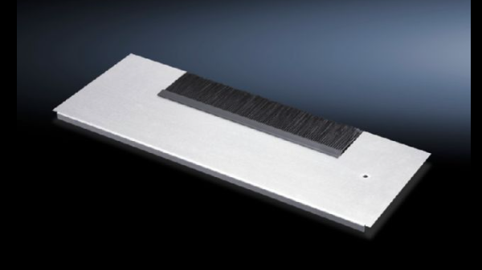  Preview
 | 2 |  |  |  | Side panel, lockable for TS, TS IT |  | 2 | pcs | Rittal, | DK 7824.220 |  | Preview | 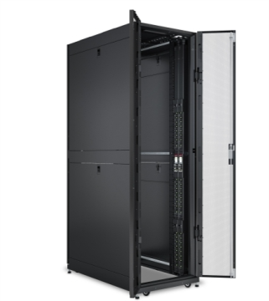  Preview
 | 3 |  |  |  | Roof-mounted fan, roof vent |  | 2 | pcs | Rittal, | SK 3139.100 |  | Preview | 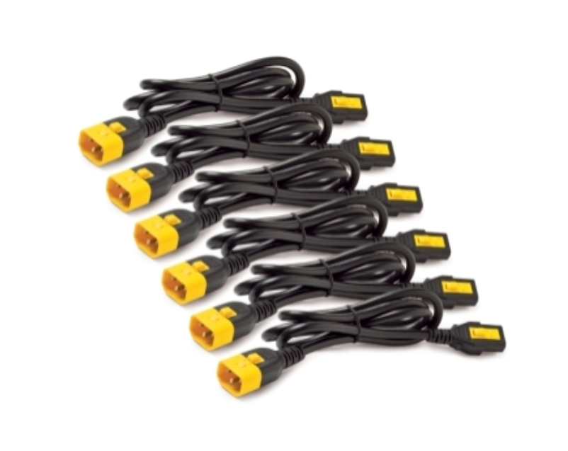  Preview
 | 4 |  |  |  | Thermostat Enclosure internal thermostat |  | 2 | pcs | Rittal, | SK 3110.000 |  | Preview | 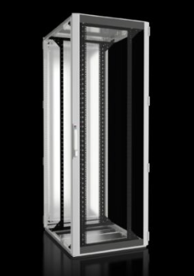  Preview
 | 5 |  |  |  | Roof plate for cable entry, two-piece for VX, VX IT, TS, TS IT |  | 2 | pcs | Rittal, | DK 7826.805 |  | Preview | 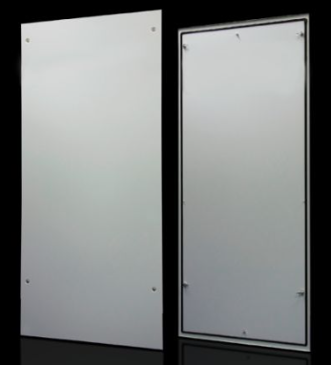  Preview
 | 6 |  |  |  | Gland plate modules for cable entry for TS, TS IT, SE |  | 2 | pcs | Rittal, | DK 7825.381 |  | Preview | 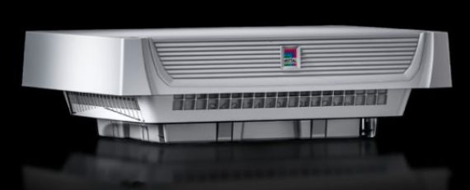  Preview
Хадгалаад илгээх

